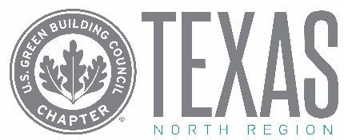
To:
From:
Re: USGBC Texas Emerging Professionals Leadership Series

Dear [Supervisor’s Name],

I’m writing to ask for approval to attend the USGBC Texas Emerging Professionals Leadership Series on March 28th, April 11th, April 25th, and May 9th, 2019 in Dallas, Texas. The 2-hr sessions that will take place over lunch, are designed to educate emerging sustainability professionals on crucial industry topics and provide networking opportunities I need to be successful in my job.

Series Sessions:
- Thursday, March 28 – Selling Sustainability: 5 Principles of Persuasion
- Thursday, April 11 – Dallas Green Building Code: The Role of Grassroots Leadership & Public Policy in Implementing Sustainable Design
- Thursday, April 25 – How Resiliency Works into Business Operations and Design
- Thursday, May 9 – Making the Case for Sustainability

While attending, I’ll be able to meet and network with peers focused on implementing sustainability programs and learn success stories and strategies from seasoned professionals from an array of industries. Between the content presented in the 4 sessions, I plan to strengthen my skills in [X], [Y] and [Z] and walk away knowing how to:
- Goal 1
- Goal 2
- Goal 3
In particular, I’d like to focus on finding best practices that could benefit these projects I am currently working on:
- [add project or initiative]
- [add project or initiative]

Here’s an approximate breakdown of attendance costs:

Transportation: (if applicable) $
Hotel: (if applicable) $
Meals: (lunch included with registration) $ 0
Event Registration Fee: (4 sessions included) $125
Total: $ XXX

I will submit a post-conference report that will include an executive summary, major takeaways, and tips. I can also share relevant information with key personnel throughout the company.

Thank you for considering my request and I look forward to your reply.

Regards,
[YOUR NAME]

